LAB6 Report Mengyang Li

Q1

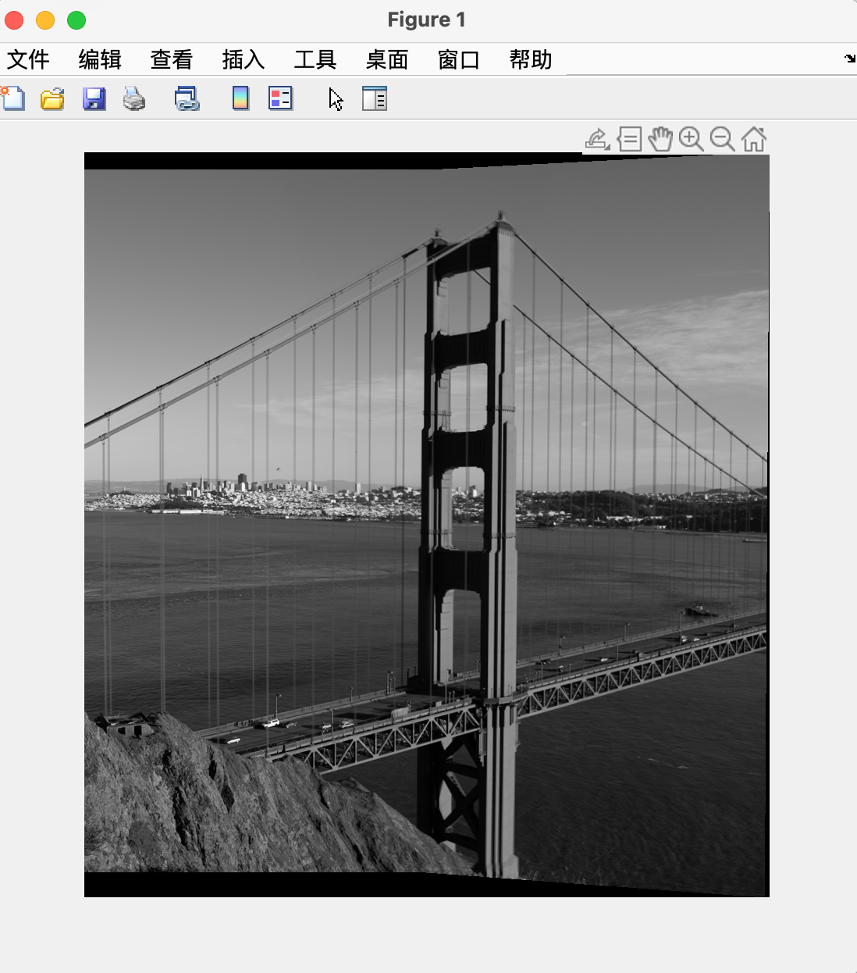

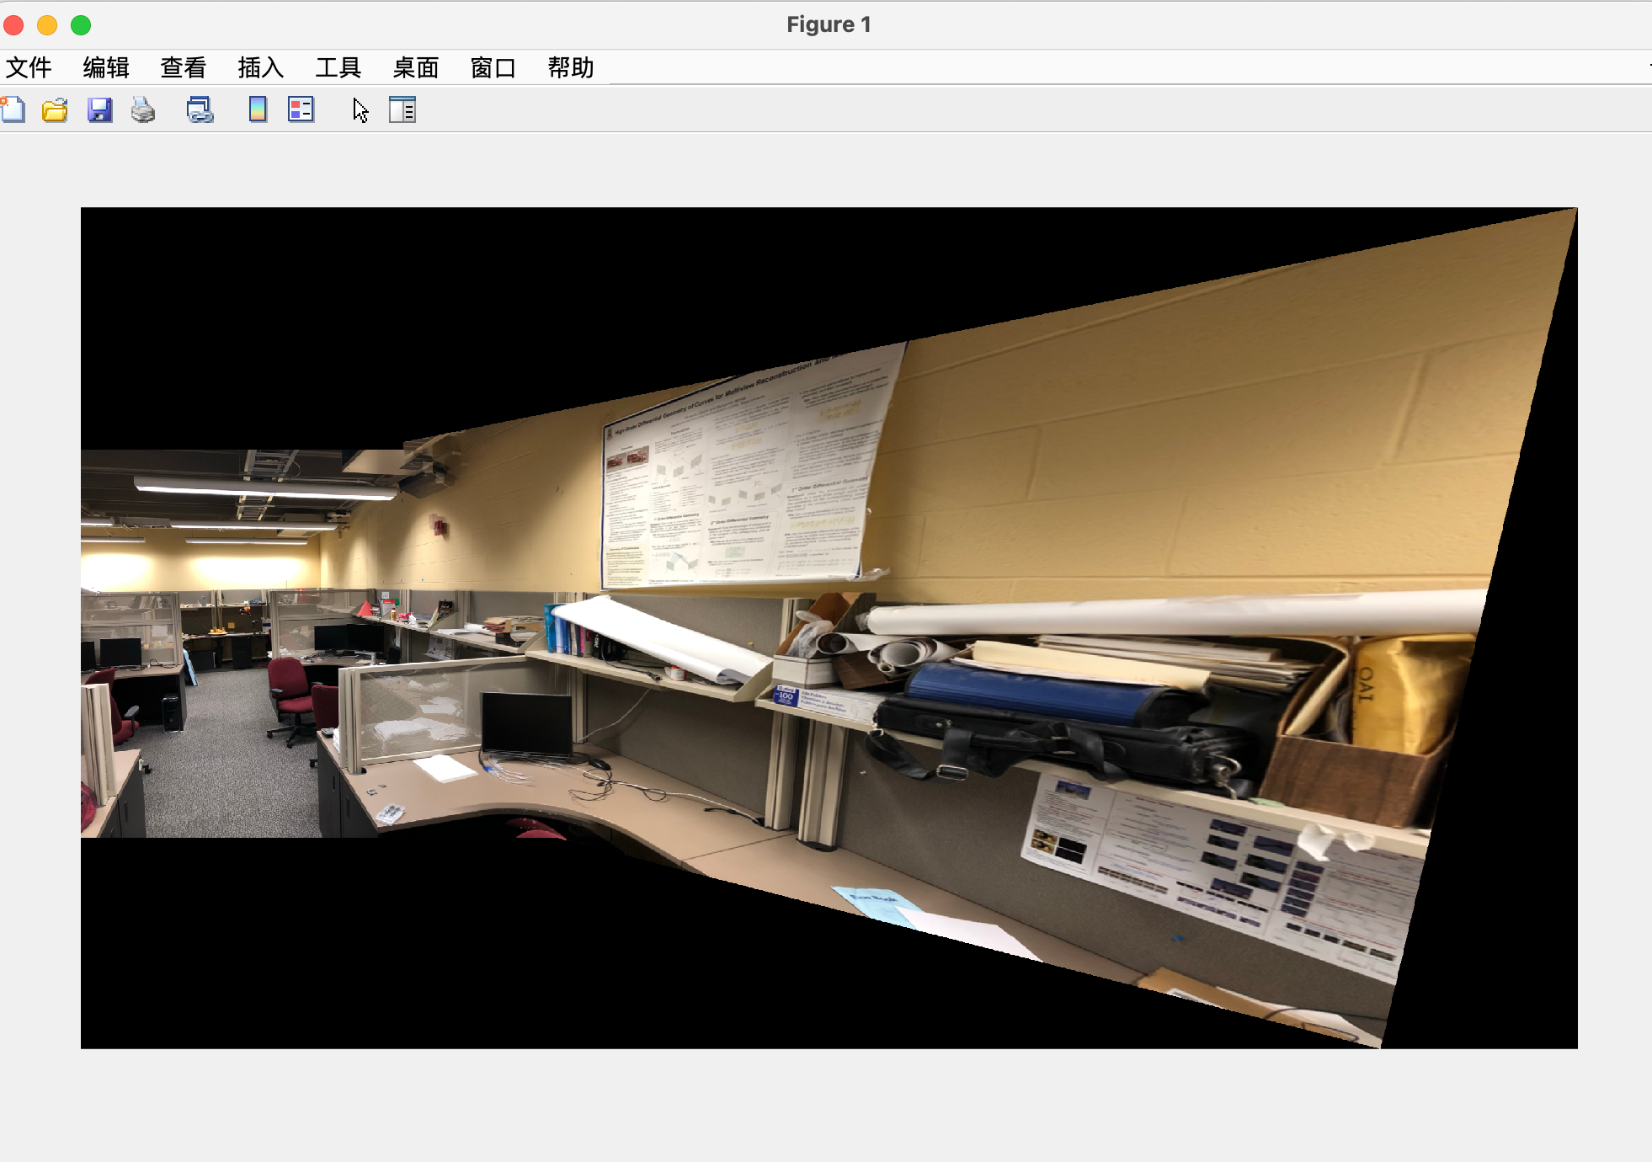

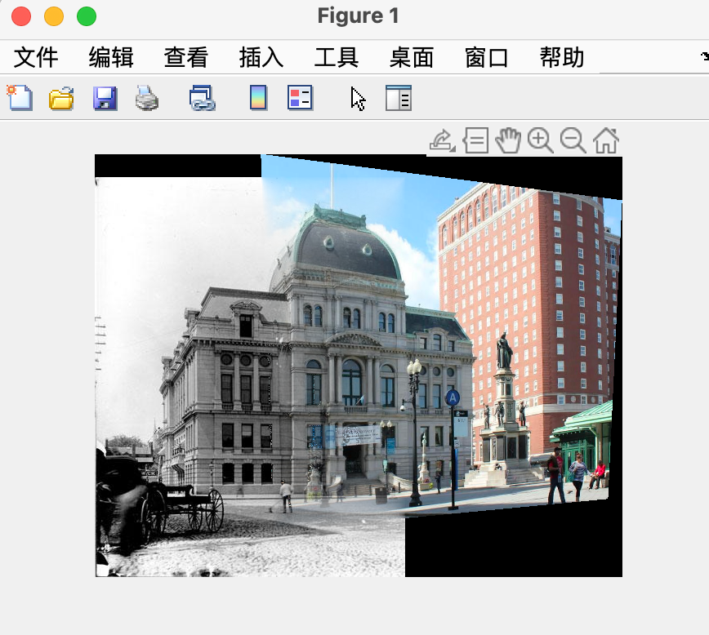

Q2

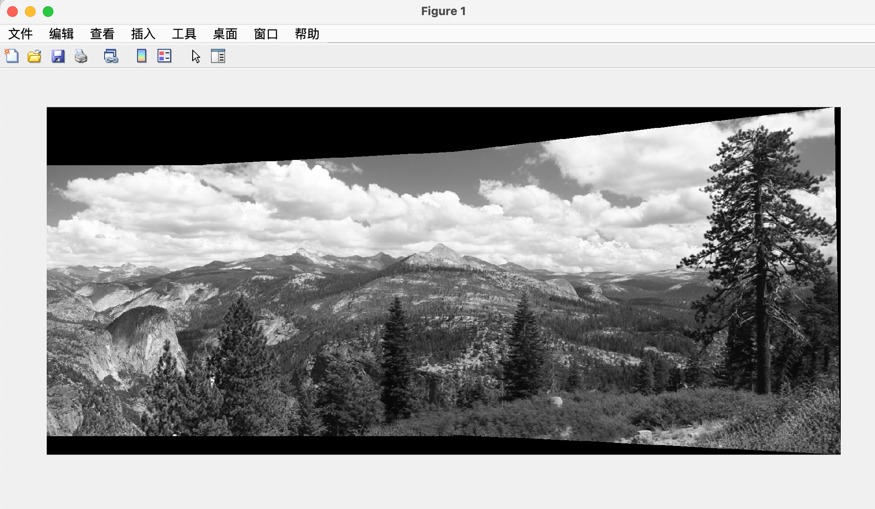

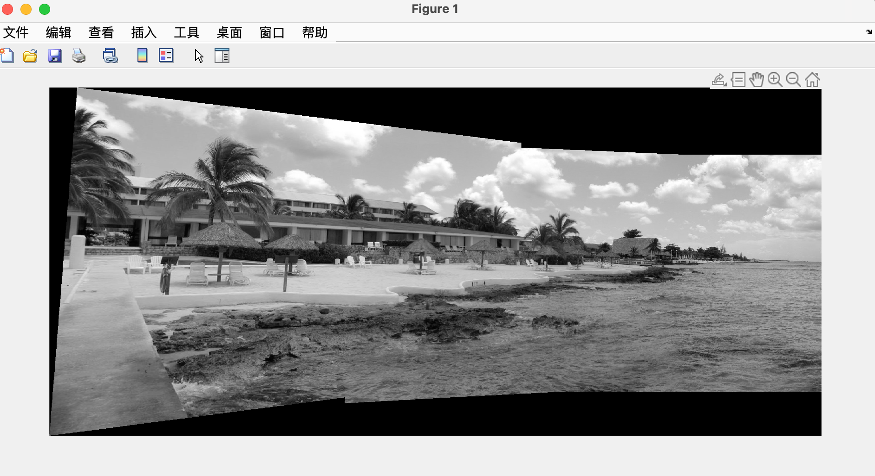

Q3

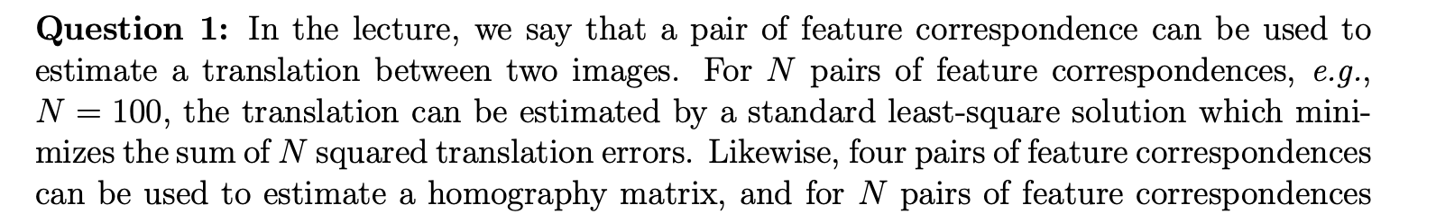



In order to estimate homography, RANSAC is used rather than a simple least-squares solution because outliers are present. Not all feature correspondences between two images are accurate in many real-world situations. There may be a lot of odd pairs. Due to the sensitivity of a simple least-squares solution to these outliers, the homography matrix is estimated incorrectly. RANSAC, on the other hand, is a reliable technique built to manage a sizable number of outliers. The method repeatedly chooses a subset of correspondences at random, computes the homography for this subset, and then counts how many correspondences from the entire set fit this homography. The best estimate is the homography with the greatest number of inliers in the outcome.

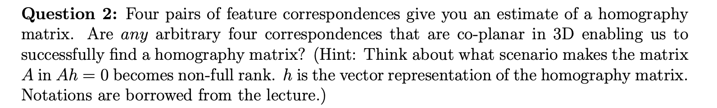

Even if four random correspondences are co-planar in three dimensions, this does not ensure a successful estimation of the homography matrix. Specifically, when the four correspondences are arranged in specific ways, the matrix A in Ah = 0 degenerates, or loses its full rank. When all four points are collinear (lying on the same line), this configuration occurs. Another instance is when they perfectly form a parallelogram. When this occurs, the rank of matrix A decreases, rendering it non-invertible when attempting to solve for the homography matrix's vector representation, h. This essentially means that there is not enough data in the set of correspondences to establish a specific homographic transformation between the two images. The chosen points should be in a general position, not on a single line or forming a perfect parallelogram, to avoid this problem.